- Brief Description:

  - Similar to popular app Flappy Bird
  - User controls a satellite
  - Satellite ‘collects’ disasters such as illegal mining and fires
  - When a disaster is collected, the users score increases
  - The user has to avoid clouds. If they hit them, the satellite is damaged
  - Game side scrolls along
  - Neural Network powered competing satellite that tries to beat the players score

- Neural Network Involvement:

  - It’s intended the Neural Network will both help the user and compete against them

    - Neural Network helps user:
      - Use real data satellite images
      - Neural network identifies emergencies
      - Creates cartoon image to overlay which the user collects

    - Neural Network competes against user
      - Neural Network also identifies emergencies
      - Pre-written script move Neural Network towards emergency, avoiding clouds
        - Does not have to avoid user as the are on ‘separate orbits’

- Difficulty level:
  - Four difficulties:
    - Easy
    - Medium
    - Hard
    - Real

  - Different speeds can be used for each difficulty
  - More clouds with each difficulty

  - On hardest difficulty mode, the Neural Network won’t create images of emergencies. User ‘sees’ what satellite sees

  - Delay in network identifying object(longer delay for easier difficulty)
  - Random move at set interval(larger intervals/no interval for harder difficulty)
      - Values to be determined, based on how game plays during implementation

  - User and Neural Network satellite have health
  - Clouds do 10 damage per sec in them
    - Easy: 150
    - Medium: 100
    - Hard: 50
    - Real: 10 (one life)
  - Once they reach zero health the satellite crashes and disappears from screen

- Controls:
  - Screen will scroll to the left
    - User uses joystick to mover within screen
    - Press button to ‘collect’ emergency

- Scoring
  - First satellite to get object gets 10 points
  - Other satellite (if it gets to the object) gets 5 points

- End Game
  - If Neural Network satellite crashes, allow user to continue until they die
  - If user dies, allow satellite to continue until they die
  - Use a two minute timer, if neither satellite dies

  - Show score on screen compared against Neural Network
    - Show high score table for other users
      - Allow user to enter details at this point

- Resources:
  - Satellite images will be stitched together into one long running stage
    - If images without a lot of emergencies present, can photo-shop additional ones
      - Use more emergencies for each successive difficulty
    - Similar situation with clouds
(Mentioned in last meeting, that last years Neural Network was able to cope with photoshopped images)
  - Cartoon images will be used for sprites and emergencies

- Potential Issues
  - Processing power of Raspberry Pi may be limited
    - Buffer Neural-Network to start processing images sometime before game starts
      - If this doesn’t work, consider using ODROID
      - Pre-Loading images with cartoon images
        - Neural Network will still use normal image during gameplay to identify emergencies
    - Data entry at end of game
      - Old-school, one letter at a time and pre-made options
      - Consider adding external keyboard

- Education value:
  - Neural Network helps user:
    - Instructions at start will explain Neural Network will identify emergencies
    - User will see cartoon object appear, perhaps with text saying Neural Network has identified another emergency
  - Neural Network helps user:
    - Statistic at end showing how many emergencies the neural network identified for you
  - Neural Network competes against user
    - Ghost overlay will show neural network moving towards objects
    - Score at end shows what neural network got

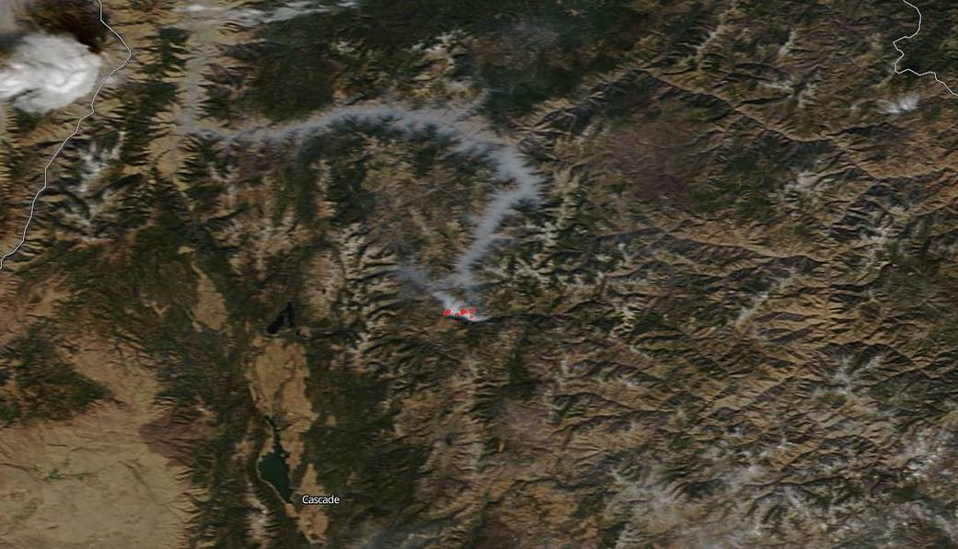

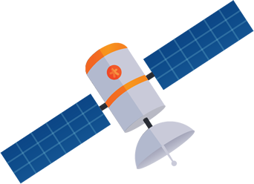
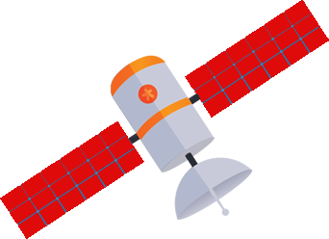

Wireframe

(Note: Clouds will be better photo-shopped than above in actual implementation)
image sources:

- Satellite(https://pngtree.com/freepng/cartoon-satellite_154692.html)
- Background(https://www.nasa.gov/sites/default/files/thumbnails/image/image-download_3.jpg)
- Fire (http://images.clipartpanda.com/fire-clip-art-red_yellow_fire_logo.png)#
- Clouds (http://www.amateurhuman.org/main/wp-content/uploads/2013/06/061413.jpg)

